MINISTRY OF SCIENCE AND EDUCATION NATIONAL TECHNICAL UNIVERSITY “KHARKIV POLYTECHNIC INSTITUTE”

DEPARTMENT OF SOFTWARE ENGINEERING AND MANAGEMENT INFORMATION TECHNOLOGIES

Report from lab#5

Discipline “Fundamentals of DataBase”

Executed by: Student of group 1.КН.201.8г

CHUKWU IRELE AMORIN

Checked by:

**Assistant Polovinka O.L.**

Kharkiv

2019

**TOPIC :** DESIGN OF COMPLEX REPORTS USING REPORT WIZARD AND THEIR MODIFICATION USING DBMS ACCESS TOOLS

**Goal:** State the laboratory practice problem. Study how to Create reports wizard for the queries using the commands

1. Create report using “Report Wizard:

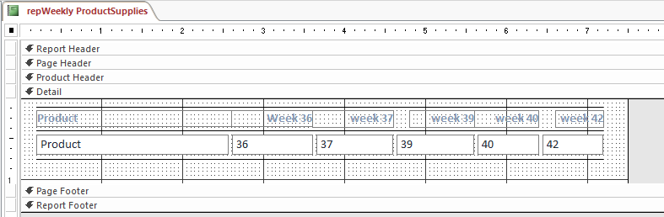

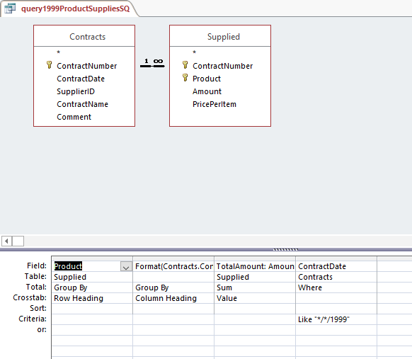

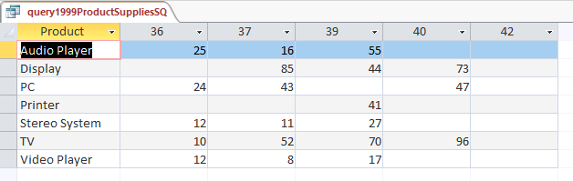

Modify the report created using “Report Wizard”:

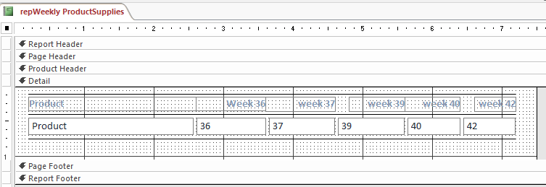

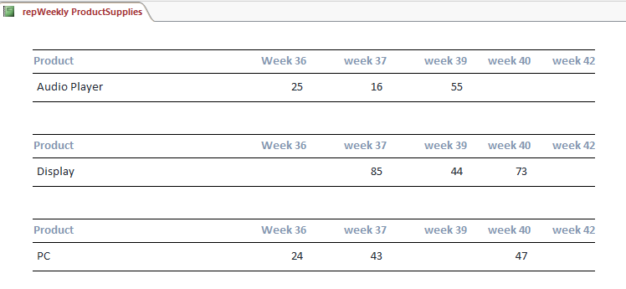

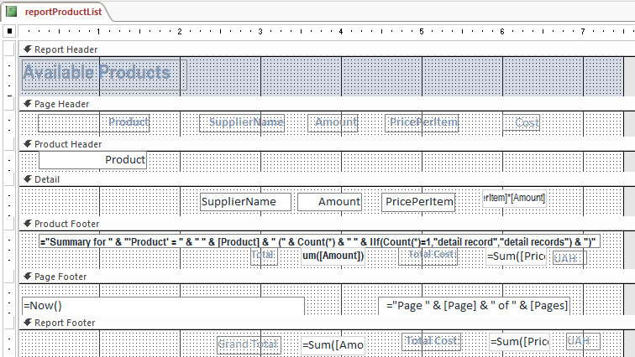

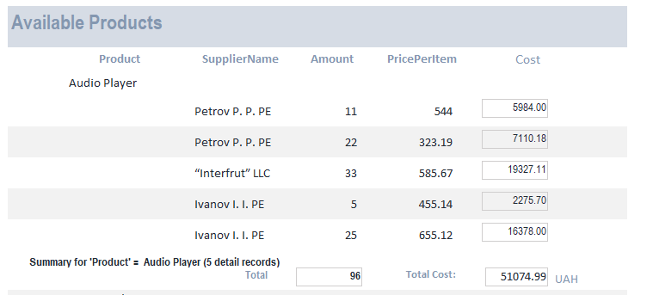

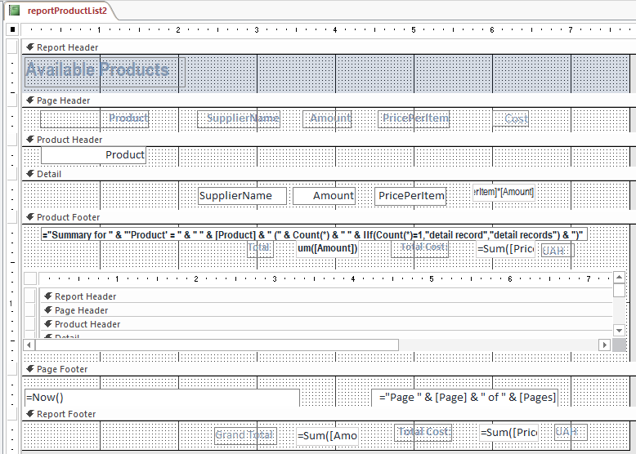

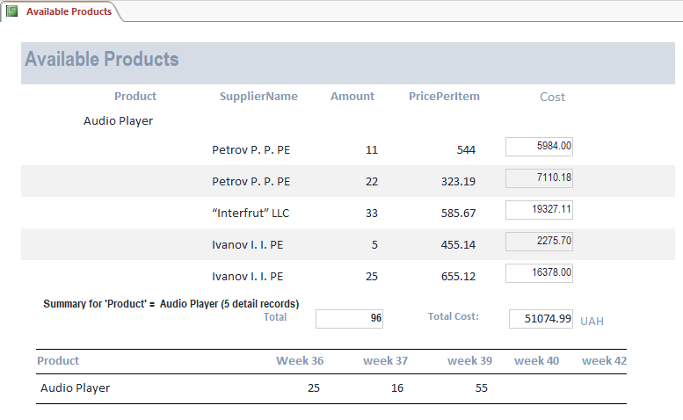

**Conclusion :**

At that lab were received knowledge about DESIGN OF COMPLEX REPORTS, it`s usage and gotten practical skills that allows To create report WIZARD to print result of queries and create tab in the Access window using DBMS Access in this environment